**You have helped Zero to reach his home**

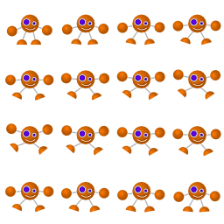

**through this dangerous labyrinth!**

**Prepare your strengths for the next one!**